[E101] Mash pump

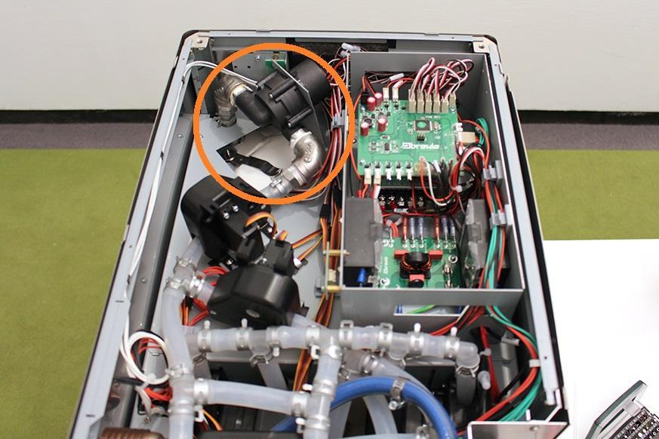

Remove the cable tie.

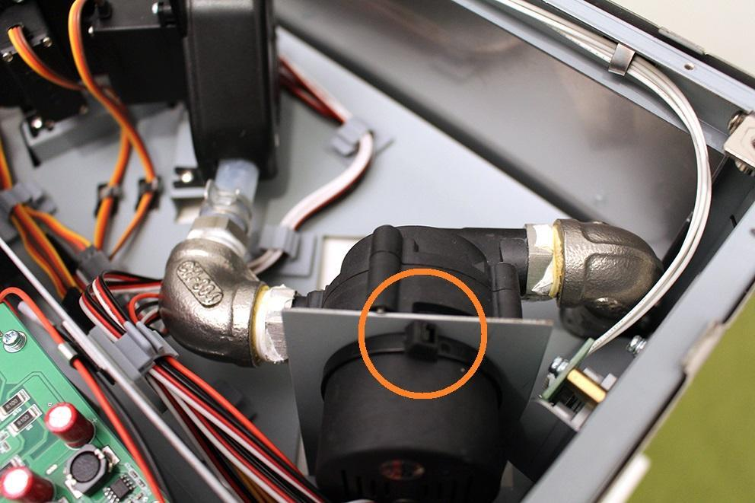

Loosen the screws of the valve next to the pump and remove the valve from its original position in order to the easier assembling.

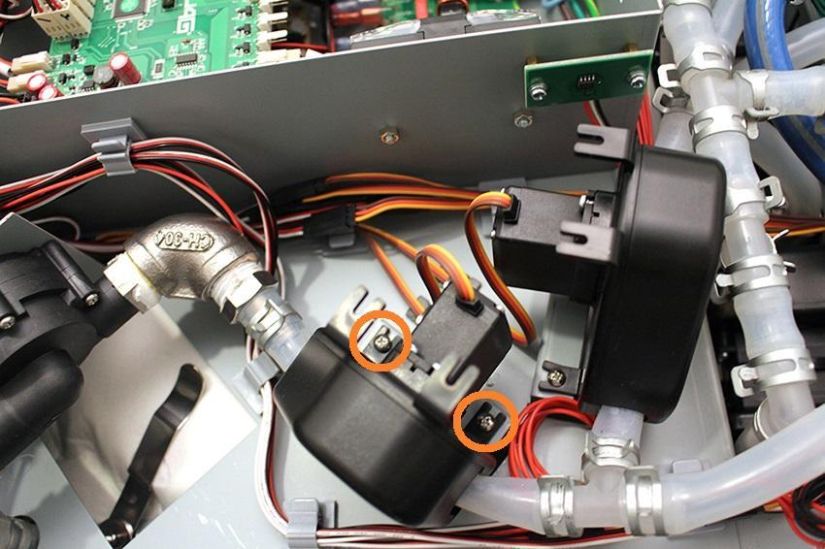

Pull off the pipe clamp from the encircled fitting.

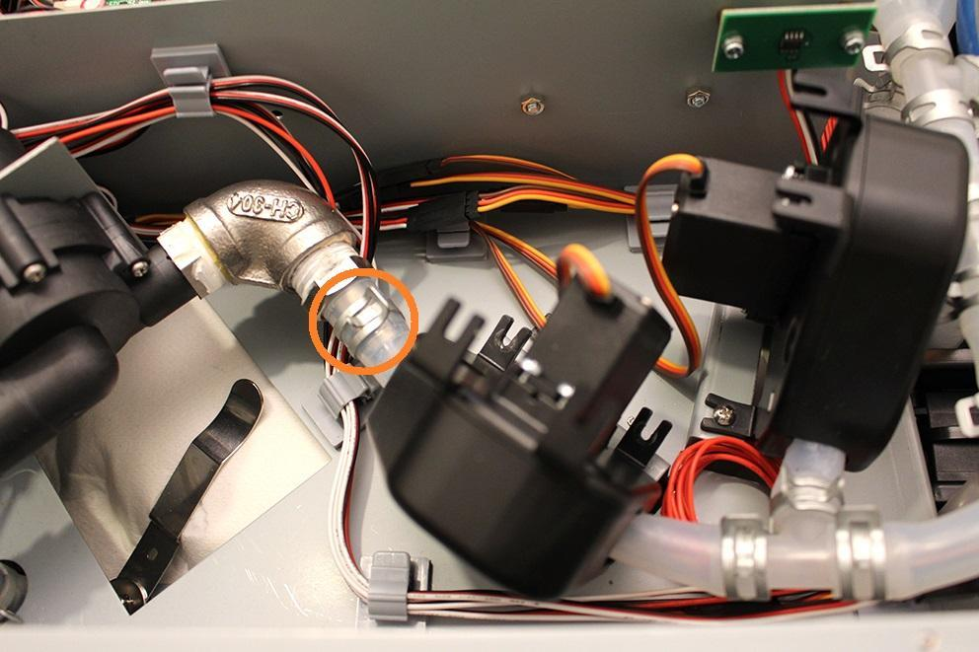

Pull off the silicone hose from the fitting.

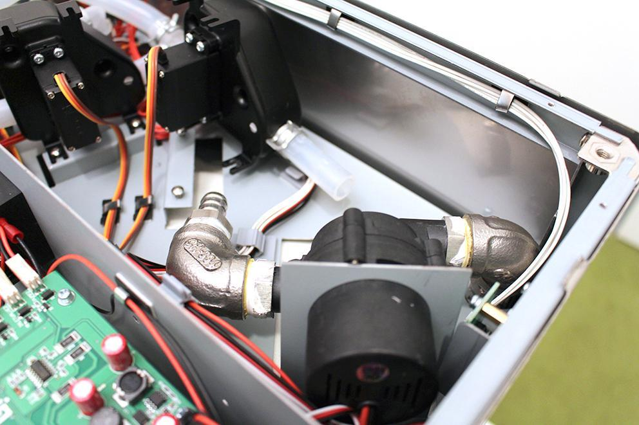

While you keep the indicated hose clamp tightly, you can pull off the pump from the silicone tube by rotating the pump around its axis.

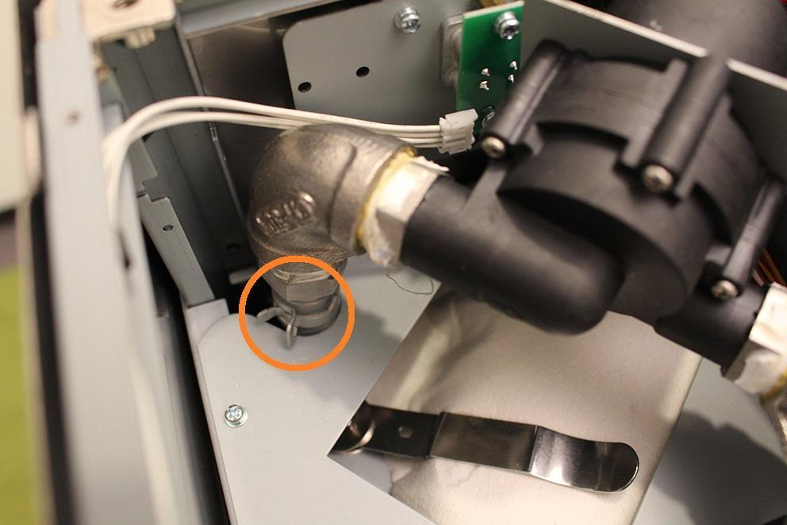

Remove the hose clamp from the interior of the machine.

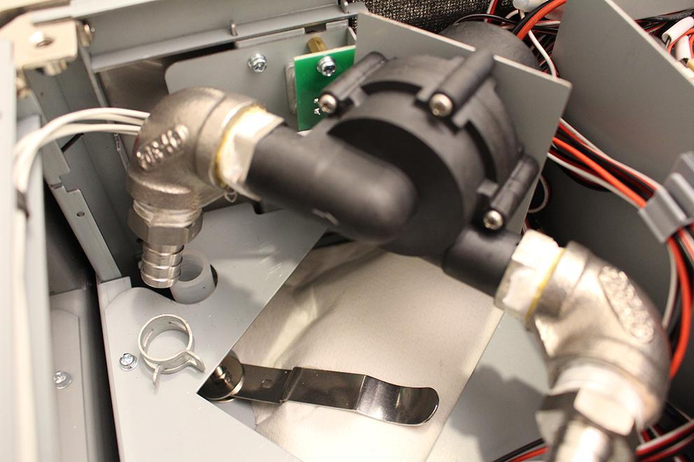

This is the plug of the pump.

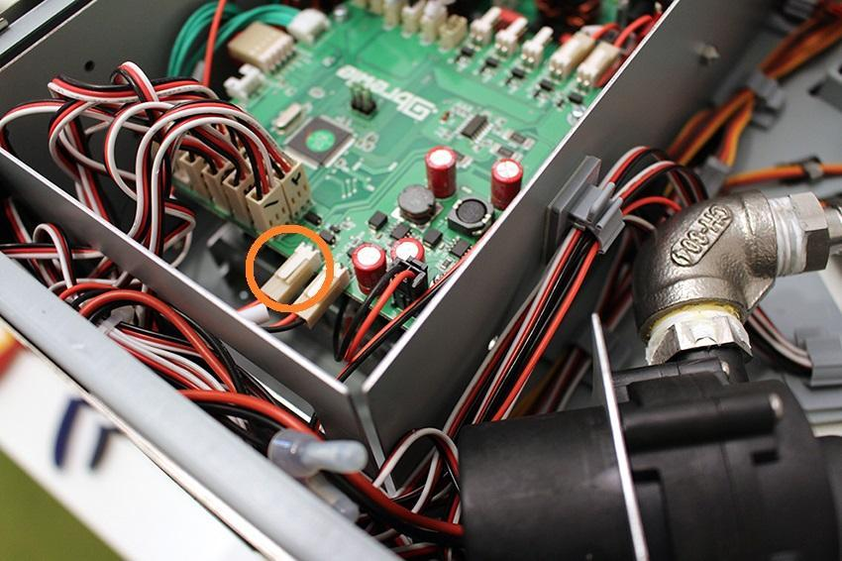

Pull off and remove it from the cable hole.

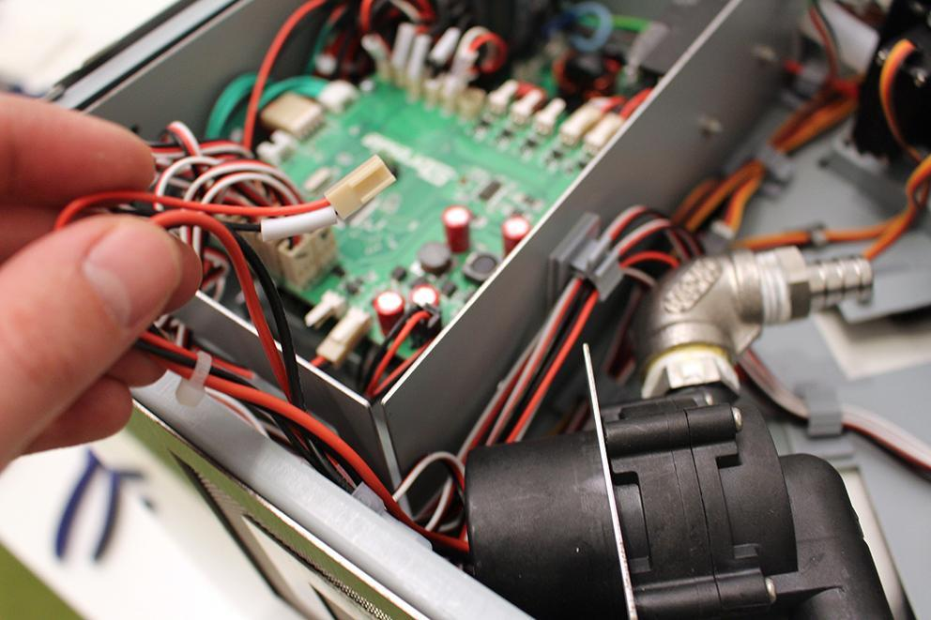

The pump is removable now.

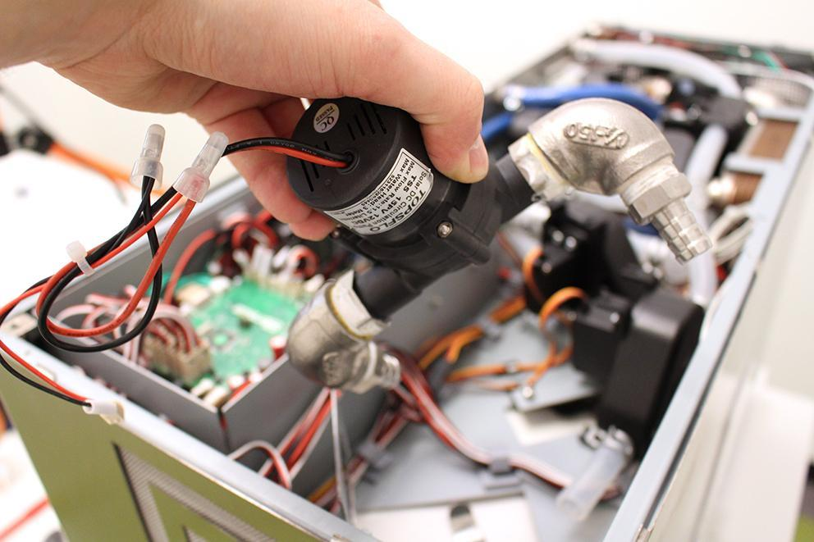

In all case you have to check if the pumps are clogged. If the pump is clogged, you dont have to replace it, you only have to clean it.

Reassemble consists of the same steps in reverse.

Make sure that the pumps are in the specified angle. Otherwise the pumps will not work properly. Use cable tie to fix the pump.

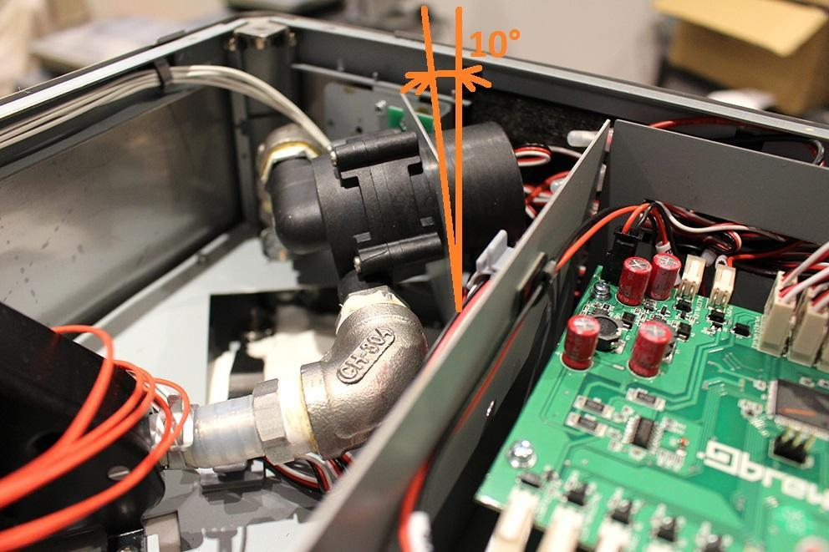

Make sure that the wort outlet hose clamp is in the proper angle. Otherwise you cannot reassemble the lower sheetmetal.

